**Assignment 9 – Kubernetes**

Name: Mohamad Haffiz Bin Mohd Hissham

**Task:**

1. Make a cluster with minikube
2. Setup docker driver
3. Create a deployment of an app of your choice
4. Check deployments and pods
5. Expose the deployment on port
6. Add minikube service and run on browser
7. Make changes on deployment and run changes in app versions
8. Create multiple pods on your app

**Steps:**

1. Use previous app (node js) created.
2. Create a new Docker Hub repository or use existing, in my case I’m using previous [repository](https://hub.docker.com/repository/docker/haffizhissham0/node_app-demo/general); using port 8081 in the code.
   1. A screenshot of a computer program

      Description automatically generated
3. Start minikube; **minikube start --driver=docker**
   1. 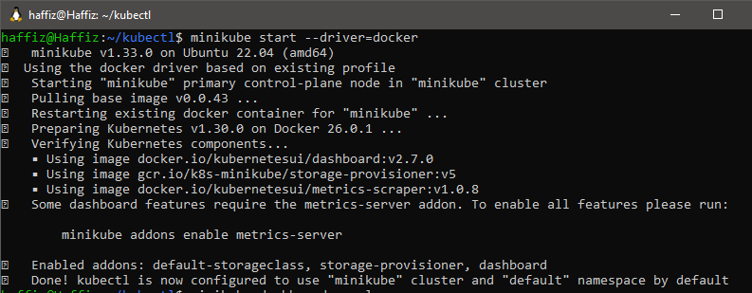
4. Run **minikube dashboard --url** to for monitoring purpose.
   1. A screenshot of a computer

      Description automatically generated
   2. A screenshot of a computer

      Description automatically generated
5. Create a deployment on K8s using latest image created from previous assignments; **kubectl create deployment node-app --image=haffizhissham0/node_app-demo:v2**, and expose the port 8081 as per code written; **kubectl expose deployment node-app --type=LoadBalancer --port=8081**
   1. 
6. Create a tunnel from cluster network to localhost network; **minikube service node-app –url**
   1. A black background with white text

      Description automatically generated
7. Access the app on localhost’s browser.
   1. A screenshot of a computer

      Description automatically generated
8. Check K8s’ dashboard for the running cluster.
   1. Take note of the pods’ name, **node-app-d49c75d7d-s5qhd**
   2. A screenshot of a computer

      Description automatically generated
9. Modify application code (refer to Sam’s [code](https://classroom.google.com/c/NjQ4MTgzNzY5Nzgw/m/Njc3NzQwNzAzMzg4/details) shared on classroom; **process.exit(0)** added in the code )
   1. A screenshot of a computer program

      Description automatically generated
10. Build a new image from the modified code, push it to docker hub.
    1. **docker build -t haffizhissham0/node_app-demo:v3** .
    2. **docker image push haffizhissham0/node_app-demo:v3**
    3. A screenshot of a computer

       Description automatically generated
    4. A screenshot of a computer

       Description automatically generated
    5. A screenshot of a computer

       Description automatically generated
11. Set the deployment to use a new image created.
    1. **kubectl set image deployment node-app node-app-demo-9qsdv=haffizhissham0/node_app-demo:v3**
    2. A screen shot of a computer

       Description automatically generated
12. Monitor the deployment on dashboard, the services should be temporarily unavailable.
    1. A screenshot of a computer

       Description automatically generated
13. K8s will automatically create a new pod with new image and terminating old pods with old image. Take a look at **~~pods' name~~ container name (in the pods)**.
    1. A screenshot of a computer

       Description automatically generated
14. A new up automatically up and running (refresh browser's tab).
    1. A screen shot of a computer

       Description automatically generated
15. Scale the deployment with another 2 pods. **kubectl scale deployment node-app --replica=3**
    1. A screenshot of a computer

       Description automatically generated
    2. A screenshot of a computer

       Description automatically generated
16. Invoke the **process.exit(0)** function to check deployment’s behaviour.
    1. A screenshot of a computer

       Description automatically generated
    2. A screenshot of a computer

       Description automatically generated
17. Check deployment dashboard, only 1 pod died but other 2 scaled pods is healthy, and the exited pod should be up and running again automatically.
    1. A screenshot of a computer

       Description automatically generated
    2. A screenshot of a computer

       Description automatically generated

**V2**

1. Create 2 YAML files. **Deployment** and **Service**.
   1. 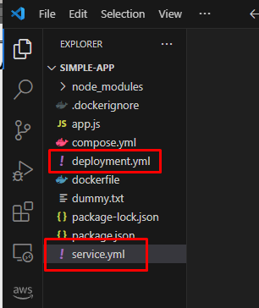
2. Copy and paste codes below.

### Deployment Code ###  
  
apiVersion: apps/v1  
# Specify type of file. eg, deployment or service  
kind: Deployment  
  
metadata:  
 # Unique key/name of the Deployment instance  
 name: node-yaml-deployment  
  
spec:  
# Number of replica should be deployed. eg, 2 Pods should exist at all times.  
 replicas: 2  
 selector:  
 matchLabels:  
 app: nodeapp  
 template:  
 metadata:  
 labels:  
 # Apply this label to pods and default  
 # the Deployment label selector to this value  
 app: nodeapp # use same app name for deployment and service #  
 spec:  
 containers:  
 - name: node-app # name for the container #  
 # Use this image for the deployment  
 image: haffizhissham0/node_app-demo:v4

### Service Code ###  
  
apiVersion: v1  
# Specify type of file. eg, deployment or service  
kind: Service  
  
metadata:  
 # Unique key of the Service instance  
 name: service-example  
spec:  
 ports:  
 # Accept traffic sent to port 80  
 - name: http  
 port: 80  
 targetPort: 8081  
 selector:  
 # Loadbalance traffic across Pods matching  
 # this label selector  
 # use same name like app label on deployment.yml #  
 app: nodeapp  
  
 # Create an HA proxy in the cloud provider  
 # with an External IP address - *Only supported  
 # by some cloud providers*  
 type: LoadBalancer

1. Start minikube service like **steps (3)** and **steps (4)**
2. Expose port for the deployment and tunnel the deployment to localhost like **steps (5)** and **steps (6)**
3. Make sure terminal are on the same directory of the YAML files
4. Run the YAML file
   1. **kubectl apply -f deployment.yml** & **kubectl apply -f service.yml**
5. Monitoring changes happening on K8s/Minikube dashboard
6. Play around by changing the image in in **deployment.yml**
   1. eg, change image:tag to prior version
   2. run the YAML again
   3. or, **alternatively** can try to edit the deployment directly
      1. **kubectl edit pod *pod_name***
      2. **kubectl edit deployment *deployment_name***
   4. monitor dashboard to see changes happening